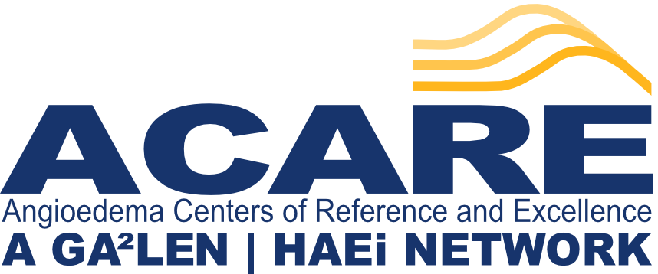

Application for an ACARE project/study

Information for applicants
ACARE projects can be applied for by individual ACAREs or several ACAREs working as a group. ACARE projects should be global projects. However, in case of special circumstances, regional/multinational projects may be supported as well. Currently, ACARE does not provide funding for projects but can help with scientific advice, ACARE office resources (communication, statistics, medical writing, ethical and regulatory issues), obtaining funding / sponsorship, and the dissemination of results. ACARE projects will be presented at ACARE meetings.

Date:

Applicant:

Name of the project:

Acronym:

Objective of the project:

Ethics approval needed/applied for?

Background of the project:

Work packages:

Duration of the project (1.5-2 years minimum):

Scope (regional / international / global):

Financing:

ACARE Office resources needed? If so, please specify:

Communication with ACAREs:

Statistical advice (depending on funding):

Medical writing (depending on funding):

Publication strategy:

Dissemination:

